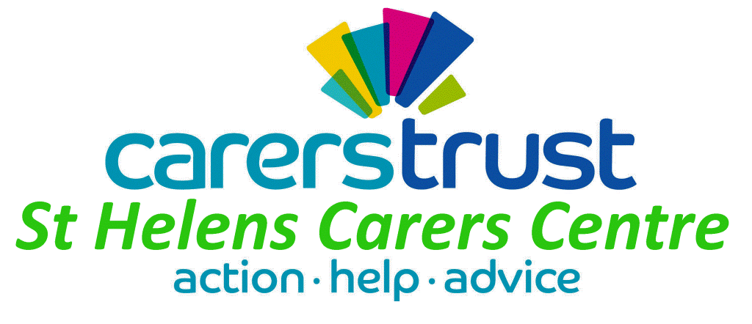

St. Helens Parent Carer Forum

THE EXPERT PARENT TRAINING COURSE

To develop parents’ knowledge and confidence
when dealing with the health system

Thursday 27th April
9.30 – 14.30
At St. Helens Young Carers Centre, Fishwick House,
18 Cotham St, St. Helens, WA10 1SJ

Katie Clarke, who delivered training to the forum last year, is back to deliver a workshop for parent carers of children with Special Educational Needs or Disabilities (SEND).

Katie is a parent carer who founded one of the first parent carer forums. Over the past 20 years, she has set up 2 charities and travelled across the country, meeting 100’s of families working to make a difference to their children’s lives and the lives of the next generation. Inspired by all the parents she meets, Katie runs workshops that are informative and have the feel good factor.

The workshop will help you to ……

- Understand how the health system works and meets the needs of children and young people with SEND
- Navigate the health system
- Get the best health outcomes for your children and young people

Here’s what other carers have said about Katie’s courses………..

“I definitely feel more confident, the workshop was very empowering and I’ve made good use of the tools I took away.”

To book a place, please ring St Helens Carers Centre on 01744 675615 or
email Sara Dolan on saradolan@sthelenscarers.org.uk.

Refreshments and lunch will be provided.

Please note that places are limited and you cannot come along without booking a place.

