SEND | Pupils with SEND | Pupils with EHC plans | Other
Number of pupils | 47 | 8 | 1 EHCP in writing
Notes
SEND Attendance:
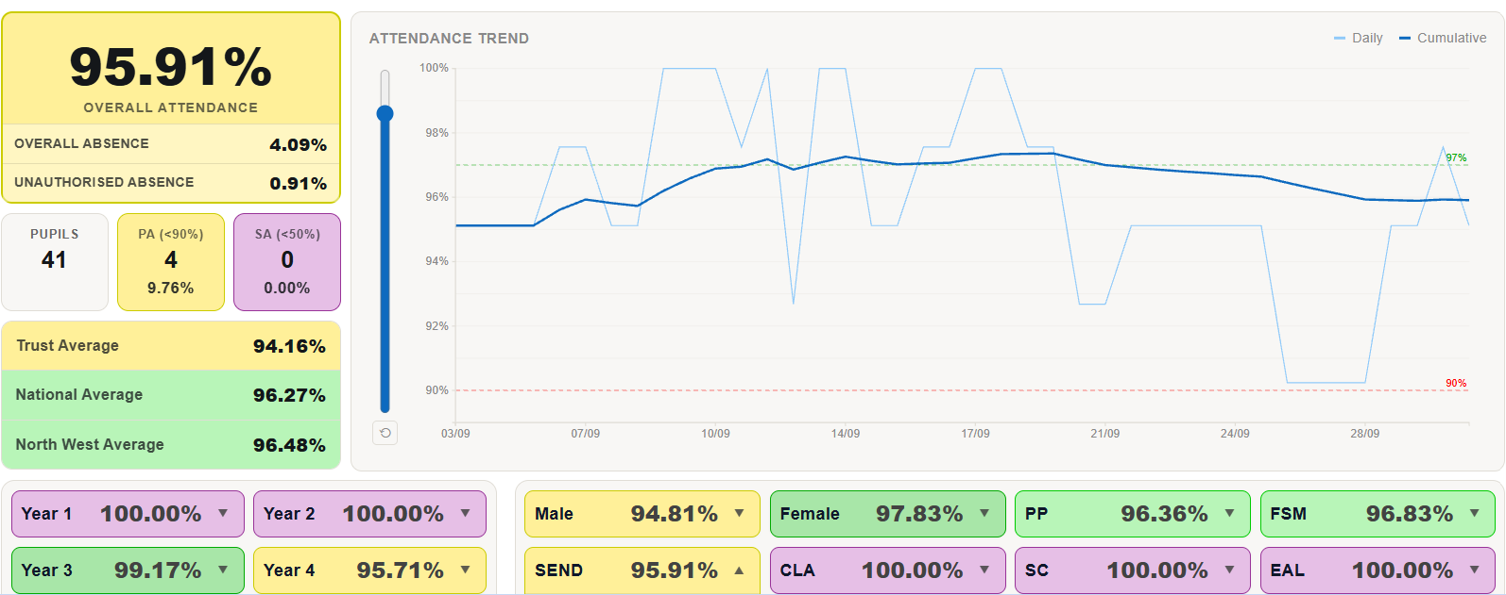
Attendance for pupils with SEND currently stands at 95.91%, which is above the Trust average of 94.16%. However this is behind the National average for SEN attendance (96.27%) and clearly below our attendance target. There are 41 pupils within the SEND cohort (Y1-Y6), with 4 pupils (9.76%) identified as persistently absent and no pupils falling into the severe absence category.
There are currently four pupils identified as persistently absent, and within a relatively small SEND cohort of 41 pupils, this has a noticeable impact on the overall attendance figure. This means that the attendance of the majority of pupils with SEND, who continue to attend school regularly, is not fully reflected in the headline percentage.
We are striving to improve our SEND attendance figure through our continued focus on therapeutic practice, inclusive provision and strong relationships with families to help pupils feel safe and supported in school. The development of calm learning environments and a strong sense of belonging across the school will also contribute positively to attendance and engagement. Reducing persistent absence remains a key priority for our school, with targeted support and close partnership working in place for those pupils and families who need additional support. The SENCO continues to run Colouring Club at 8:30 each morning to provide a ‘soft start’ for pupils who are continually finding it difficult to come to school in the morning.
Therapeutic Classrooms – Implementation and Impact:
As part of our commitment to developing an inclusive and nurturing learning environment, we have continued to enhance all classrooms in line with LDST Enabling Environments guidance and therapeutic classroom principles (use of low lighting, flexible seating, plants in the environment, use of calm music). Each classroom has been provided with a lamp and plant to create a warmer, more welcoming atmosphere. Flexible seating options have also been introduced to support pupils' individual sensory, emotional and learning needs.
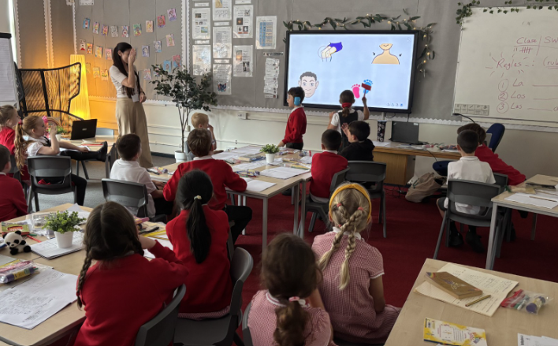
[Year 3 featuring soft lighting, plants and flexible seating options]
Staff have carefully considered the classroom environment and worked hard to ensure that classrooms are calm, organised and predictable spaces where pupils feel safe and valued. These changes complement our wider therapeutic approach and reflect our understanding that pupils learn best when they feel like they belong.
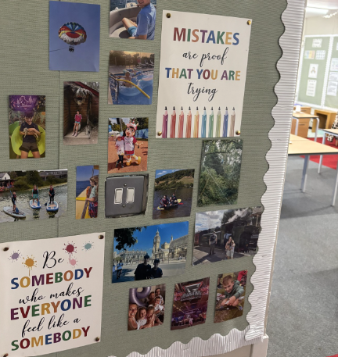
[Year 5’s Belonging Wall featuring a photograph of every child]
The changes are already contributing to calmer learning environments across the school. Pupils are more settled and ready to learn and staff report improvements in engagement, concentration and self-regulation. We hope that having a consistent approach across school will strengthen pupils' sense of belonging and help to create environments where all children feel valued as members of their class community. Pupil voice to be undertaken this half-term.
Sensory Circuits Update:
As part of our ongoing work to support pupils' sensory and regulation needs, we are improving our three sensory circuit stations across the school. One station is already established in Lower Key Stage 2, with further stations in Key Stage 1 and Upper Key Stage 2 planned for implementation before Christmas.
Each station is set up around the three stages of a sensory circuit: alerting, organising and calming. When using the station, pupils choose an activity from each stage and use a 1-minute timer for each activity before moving to the next. Pupils will be able to access a range of practical activities and resources within each area, helping them to achieve the level of regulation needed to engage successfully in learning.
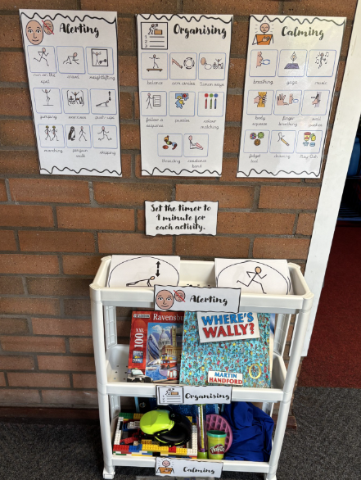
The stations will be used by pupils identified by teachers and the SENCO at scheduled points throughout the day as part of their individual provision. This targeted support will work alongside our existing whole-class sensory circuits to make sure that pupils who need additional sensory input have regular opportunities to regulate in a structured and consistent way.

PATHS Preschool:
Since introducing the Barnardo’s PATHS programme across school, we have seen a positive impact on pupils’ social and emotional development with children becoming more confident in recognising and talking about their feelings, using strategies to regulate their emotions, and resolving disagreements with more independence (impact measured through staff and pupil voice and pre/post data gathered by our PATHS coordinator). The consistent language and approaches used throughout the school continue to support our inclusive environment and improve emotional regulation.
Following the positive impact of PATHS across the rest of school, we are now excited to extend the programme into our preschool through fortnightly sessions delivered by a Barnardo’s practitioner. By introducing social and emotional learning at an earlier stage, we aim to support children in developing emotional regulation, communication, resilience and positive relationships before they begin Reception. We hope that this early intervention will help ensure our pupils start school with strong foundations for learning, wellbeing and successful engagement with school life.
Individual Support Plans (Assess, Plan, Do, Review):
Every pupil on the SEN register has a personalised plan that includes information about their strengths, interests, what is important to them and the strategies that help them learn successfully in school. The plans also include individual targets, which are reviewed and updated each term by class teachers and the SENCo. These are shared and discussed with parents during termly review meetings to ensure everyone is working towards the same goals.
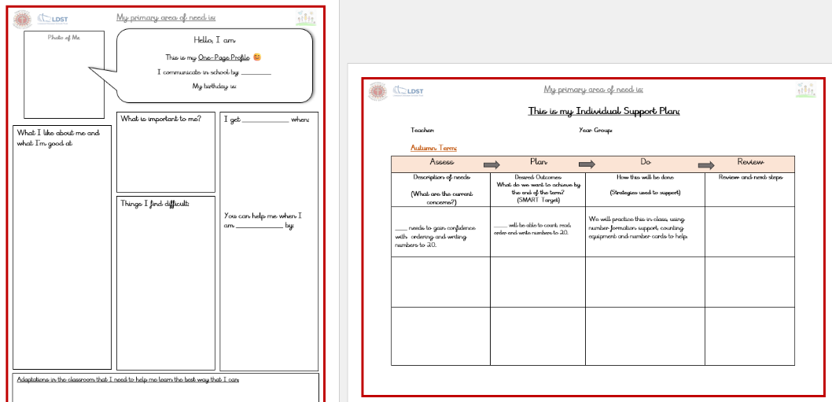
We have used Helping Hands Plans for several years and they have been a valuable way of capturing pupil voice and ensuring support is tailored to individual needs. This year, we are moving to an updated Individual Support Plan format. This will bring our documentation in line with other schools across LDST and provide a clearer record of the Assess, Plan, Do, Review process. The new format still places the pupil at the centre of the plan while making it easier to show the identified need behind each target and the strategies that will be needed to help each pupil achieve the outcomes in their plan.

