Rainbow Spellings

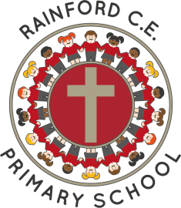
Year 1

Name: _________________________
Autumn 1  Red | Autumn 2  Orange | Spring 1  Yellow
the  a  to  is  I  we  be  he | she  me  was  today  said  are  were  no | my  by  go  so  put  do  has  of  says  ask
Spring 2  Light-green | Summer 1  Dark-green | Summer 2  Light-blue
his  you  your  our  house  they  here  there  where  one | once  love  come  some  friend  school  push  pull  full | Any 20 from the whole list

Things Good Spellers Do

- Say the word slowly and listen to the sounds.
- Think about other words with the same/similar letter patterns.
- Break the word into parts (chunking).
- Break the word into syllables.
- Find smaller words within bigger words.
- Highlight the ‘tricky’ part.
- Think about the root word and then add prefixes or suffixes.
- Use memory tricks to help (mnemonics).
- Remember taught spelling rules.
- Learn spelling lists.
- Look at the word to check it looks right.
- Say the word how it is spelt.

