Rainbow Spellings

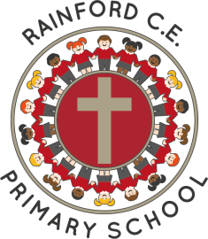
Year 2

Name: _________________________
Autumn 1  Dark-blue | Autumn 2  Pink | Spring 1  Purple
door  floor  poor  old  cold  gold  hold  told  Mr  Mrs | great  kind  find  mind  behind  water  last  past  fast  Christmas  people | most  grass  pass  plant  bath  path  class  would  could  should  even  eye
Spring 2  Bronze | Summer 1  Silver | Summer 2  Gold
beautiful  because  child  children  steak  break  only  many  father  after  again  money  wild  half  hour  any | prove  improve  move  both  climb  busy  sure  sugar  parents  clothes  every  everybody  pretty  whole  who | Any 20 from the whole list

Things Good Spellers Do

- Say the word slowly and listen to the sounds.
- Think about other words with the same/similar letter patterns.
- Break the word into parts (chunking).
- Break the word into syllables.
- Find smaller words within bigger words.
- Highlight the ‘tricky’ part.
- Think about the root word and then add prefixes or suffixes.
- Use memory tricks to help (mnemonics).
- Remember taught spelling rules.
- Learn spelling lists.
- Look at the word to check it looks right.
- Say the word how it is spelt.

