Rainbow Spellings

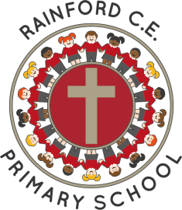
Year 3

Name: _________________________
Autumn 1  Red | Autumn 2  Orange | Spring 1  Yellow
busy  circle  earth  eight  February  fruit  group  learn  often  woman | build  early  earth  heard  heart  remember  special  strange  (al)though  women | answer  centre  decide  difficult  enough  length  minute  notice  perhaps  question
Spring 2  Light-green | Summer 1  Dark-green | Summer 2  Light-blue
caught  complete  describe  different  eighth  guide  height  quarter  sentence  weight | address  appear  certain  continue  exercise  favourite  naughty  possible  straight  surprise | Any 20 from the whole list

Things Good Spellers Do

- Say the word slowly and listen to the sounds.
- Think about other words with the same/similar letter patterns.
- Break the word into parts (chunking).
- Break the word into syllables.
- Find smaller words within bigger words.
- Highlight the ‘tricky’ part.
- Think about the root word and then add prefixes or suffixes.
- Use memory tricks to help (mnemonics).
- Remember taught spelling rules.
- Learn spelling lists.
- Look at the word to check it looks right.
- Say the word how it is spelt.

