Rainbow Spellings

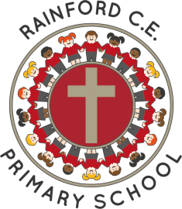
Year 4

Name: _________________________
Autumn 1  Dark-blue | Autumn 2  Pink | Spring 1  Purple
actual(ly)  consider  extreme  famous  forward  history  popular  potatoes  pressure  therefore | breath  breathe  disappear  grammar  guard  interest  mention  opposite  promise  thought | accident(ally)  bicycle  century  important  island  material  natural  ordinary  position  probably  through
Spring 2  Bronze | Summer 1  Silver | Summer 2  Gold
believe  experiment  imagine  increase  occasion(ally)  possess  purpose  recent  regular  strength  suppose | business  calendar  experience  knowledge  library  medicine  particular  possession  reign  separate  various | Any 20 from the whole list

Things Good Spellers Do

- Say the word slowly and listen to the sounds.
- Think about other words with the same/similar letter patterns.
- Break the word into parts (chunking).
- Break the word into syllables.
- Find smaller words within bigger words.
- Highlight the ‘tricky’ part.
- Think about the root word and then add prefixes or suffixes.
- Use memory tricks to help (mnemonics).
- Remember taught spelling rules.
- Learn spelling lists.
- Look at the word to check it looks right.
- Say the word how it is spelt.

